World Day for Refugee and Migrants

This Sunday is the Catholic Church’s day for remembering and praying for Refugees and Migrants. We will use the Feast of St Michael to focus our prayers. If you can come to Mass on Tuesday at 10.00am great if not then try to take the time to visit the church for a quiet prayer. I have alsoattached the newsletter again for those who are new to the parish email list.

If you are joining Miriam tomorrow at 6.40 on the

Dawn Meditation Walk

then you might as you walk remember those who were forced to flee from war, persecution or biting poverty. Meet at the car park beside Musselburgh Lagoons boating lake. I have taken this prayer and the prayer intentions form the Vatican Website.
Best wishes Fr Basil
Like Jesus Christ, forced to flee

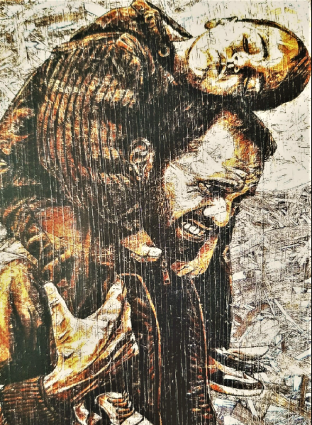

PRAYER
Father, you entrusted to Saint Joseph what you held most precious: the
child Jesus and his Mother, in order to protect them from the dangers
and threats of the wicked.

Grant that we may experience his protection and help. May he, who
shared in the sufferings of those who flee from the hatred of the
powerful, console and protect all our brothers and sisters driven by war,
poverty and necessity to leave their homes and their lands to set out as
refugees for safer places.

Help them, through the intercession of Saint Joseph, to find the strength
to persevere, give them comfort in sorrows and courage amid their trials.
Grant to those who welcome them some of the tender love of this just
and wise father, who loved Jesus as a true son and sustained Mary at
every step of the way.

May he, who earned his bread by the work of his hands, watch over
those who have seen everything in life taken away and obtain for them
the dignity of a job and the serenity of a home.

We ask this through Jesus Christ, your Son, whom Saint Joseph saved by
fleeing to Egypt, and trusting in the intercession of the Virgin Mary,
whom he loved as a faithful husband in accordance with your will.
Amen.

Prayer Intentions

1. For our Pope Francis and for our bishops who are pastors of local churches, so that the Spirit of Jesus, who emptied Himself to walk with humanity, might impel them to be prophets of a Church that welcomes, protects, promotes and integrates all people, especially the most vulnerable. Let us pray.

2. For all migrants and people on the move, especially for internally displaced persons to whom this World Migrant and Refugee Day is dedicated: may they feel the concern and proximity of the Church throughout the world. Let us pray.
3. For solidarity between peoples and nations: may we all become ever more aware of being one human family under the merciful gaze of God, especially at this time of global crisis due to COVID-19. Let us pray.

4. For all those who have been affected by or have died as a result of COVID-19, especially for internally displaced persons whose condition has been aggravated by this virus, to find comfort, compassion and support in the Christian community. Let us pray.

5. For an ever greater understanding of the situation of internally displaced persons throughout the world and in each of our nations, that the Lord may guide us to be attentive and open our eyes to the needs and sufferings of our brothers and sisters who are forced to move. Let us pray.

6. For reconciliation and solidarity between people and peoples, so that, with the help of the Spirit of peace, peaceful solutions can be reached to the armed conflicts that cause the forced displacement of millions of people. Let us pray.

7. For the missionary and pastoral conversion of every Christian and of all Christian communities: may the Spirit accompany us to be “like minded in Christ”. Let us pray.

8. For the Church, God's people with so many faces, that it may forcefully promote and build a new, just and supportive humanity in which migrants, refugees and internally displaced persons are active and preferential actors. Let us pray.

9. For all Christian communities to become agents and promoters of the cause of justice in situations of corruption, inequality, indifference and oppression. Let us pray.

10. For the protection of Creation given to us by God, that the people of God may be the attentive and caring guardians of our common home. Let us pray.

---------------------------------------------

Tuesday 29TH SEPTEMBER: FEAST OF SS MICHAEL, GABRIEL AND RAPHAEL

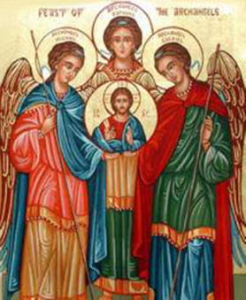

The liturgy celebrates the feast of these three archangels who are venerated in the tradition of the Church.
Michael (meaning Who is like God?) was the archangel who fought against Satan and all his evil angels, defending all the friends of God. He is the protector of all humanity from the snares of the devil. Patron saint of paramedics; police officers; radiologists; sailors; soldiers and those in need of protection.
Gabriel (meaning Strength of God) announced to Zachariah the forthcoming birth of John the Baptist, and to Mary, the birth of Jesus. His greeting to the Virgin, "Hail, full of grace," is one of the most familiar and frequent prayers of the Christian people. Patron saint of ambassadors; broadcasting; childbirth; clergy; post office; diplomats and messengers.
Raphael (meaning Medicine of God) is the archangel who took care of Tobias on his journey. Patron saint of the blind; counsellors; guardian angels; mental illness; nurses; pharmacists; physicians and shepherds.

The Catechism of the Catholic Church teaches us that, "The existence of the spiritual, non-corporeal beings that Sacred Scripture usually calls "angels" is a truth of faith. The witness of Scripture is as clear as the unanimity of Tradition." Angels are pure, created spirits. The name angel means servant or messenger of God. Angels are celestial or heavenly beings, on a higher order than human beings. Angels have no bodies and do not depend on matter for their existence or activity. They are distinct from saints, which we can become. Angels have intellect and will and are immortal. They are a vast multitude, but each is an individual person. Archangels are one of the nine choirs of angels listed in the Bible.

